Development of IoT Based Logistic Vehicle Maintenance System
Alternate Title:
Heavy Vehicle Monitoring System Using Android Application
Objective:
The aim of this project is to build a heavy vehicle monitoring system which is used to monitor the parts of heavy vehicles like engine temperature, fuel level, carbon emission, cabin environment, radiator etc. The monitoring system is done by android app.
Abstract:
Nowadays heavy vehicle plays a major role in transportation. Heavy vehicles carry 71.3% of freight transported over land. Heavy vehicles function as part of a logistics chain whose components also include inland waterways, shipping, air and rail transport. The other transport modes also depend on Heavy vehicles to transfer freight to and from depots, rail terminals, airfields and ports. Whether you have Heavy vehicles delivering stock, logistics vehicles or any other type of truck fleet, as a major part of your business it’s important that each vehicle is safe to be on the road. As you would with a car, having repairs done and regular maintenance is the best way of ensuring small problems do not progress into dangerous issues.

From dashboard warning lights to strange noises coming from your exhaust, you should never ignore any of these signs. In most cases, you’ll find that the repair is an easy fix, and bringing your vehicle to a professional garage or service centre is your best bet. Driving a vehicle that’s in need of a repair could be very dangerous. Unexpected problems may arise as you’re driving, putting you and other road users at risk of a traffic accident, so to avoid this we proposed a heavy vehicle maintenance system. The system is equipped with smart microcontroller, gas sensor, vibration sensor, temperature and humidity sensor, liquid level sensor, voltage sensor, NodeMCU and a 16x2 LCD.

Through this system we will be able to monitor the health of heavy vehicles and take action in advance to keep the vehicle in good condition.

Existing System:
In existing system development of IoT Based Logistic Vehicle Maintenance system has been developed using both hardware and software. Two main microcontrollers which are Arduino UNO and NodeMCU will be used to collect the sensor reading from DHT11 sensor and two pressure transducer sensors and then send the data to the MySQL database.

Proposed System:
The proposed heavy vehicle maintenance system monitors the parameters of heavy vehicles and gives the data of the parts and the system can be monitored through android application via node MCU and it sends the data to cloud database. Through this system we can avoid vehicle failures and we ensure the health condition of the vehicle.

BlockDiagram: 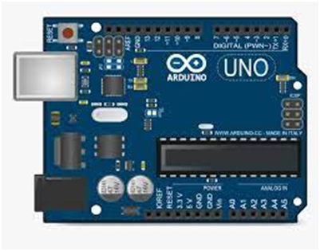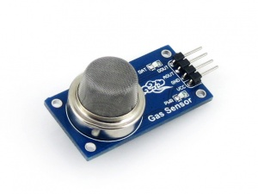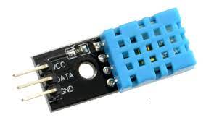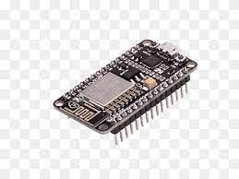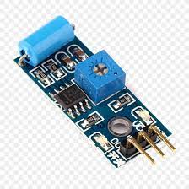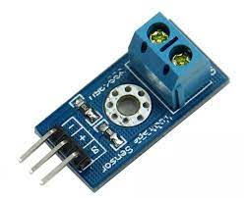
Gas Sensor
Water Level Sensor
Voltage Sensor
Temperature Sensor
16x2 LCD
Node MCU
Cloud Database
Android Application
Vibration Sensor
Arduino UNO
Hardware Requirements:
- Arduino UNO
- Node MCU
- Vibration Sensor
- Gas Sensor
- Water level Sensor
- Voltage Sensor
- Temperature and Humidity Sensor
- 16xLCD
- Android Mobile

Software Requirements:
- Arduino IDE
- Android Studio

